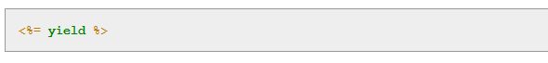

This code is responsible for inserting the contents of each page into the layout.

Using this layout ensures that visiting the page (for example /pages/home) converts the contents of home.html.erb to HTML and then inserts it in place of <%= yield %>.